229旅童軍團集會程序表

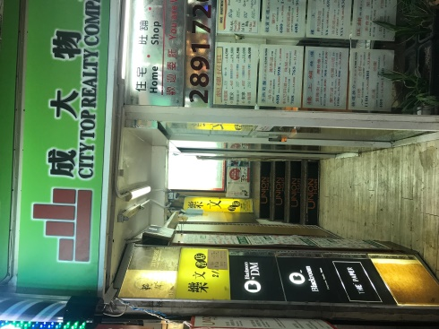
日期 : 2018-6-01 SAT
時間: 1600-1800
地點: 銅鑼灣駱克道508號4樓
(樂文書局上兩層 / 義順牛奶側 /門口有成大物業 )
主題 : 急救
訓練員: Katie, Alicia, Tiffany
當值領袖: Madam Isa + Guest Speaker Lau Sir, St John’s Ambulance
值日小隊 : 狐
Duty SPL : 虎
Time |  | In Charge
16:00 | Fall in; roll call; intro of guest speaker | Madam Isa
16:15 | Case study | Lau Sir
16:40 | Demo + Practice | Lau Sir + Ventures
17:15 | Lecture + Q&A | Mdm Isa
17:55 | 宣佈事項 / 降旗 / 解散 / 執拾 /清理場地 | 全體領袖/ Duty Patrol
18:00 | 執拾 /清理場地 | Duty Patrol

Remarks:
- Wear outdoor uniform with scout scarf. (Yellow tee or HKUGA PE top)
- Each scout must bring along :
  - 1 roll of 3” bandage
  - 1 roll of 2” bandage
- The venue is a rented classroom by the name 藝.牽 Tel: 5547-1109; no lift, walk up the stair case to the top floor. Call Mdm Isa at 964-2949 if your PL or PS cannot be reached

