229 Scout & Venture Sections 2014 Xmas cum Orientation Camp

Dates: 20-22 DEC 2014 (SAT-MON)
Venue: 大埔汀角路洞梓100號洞梓童軍中心
Venue Information :
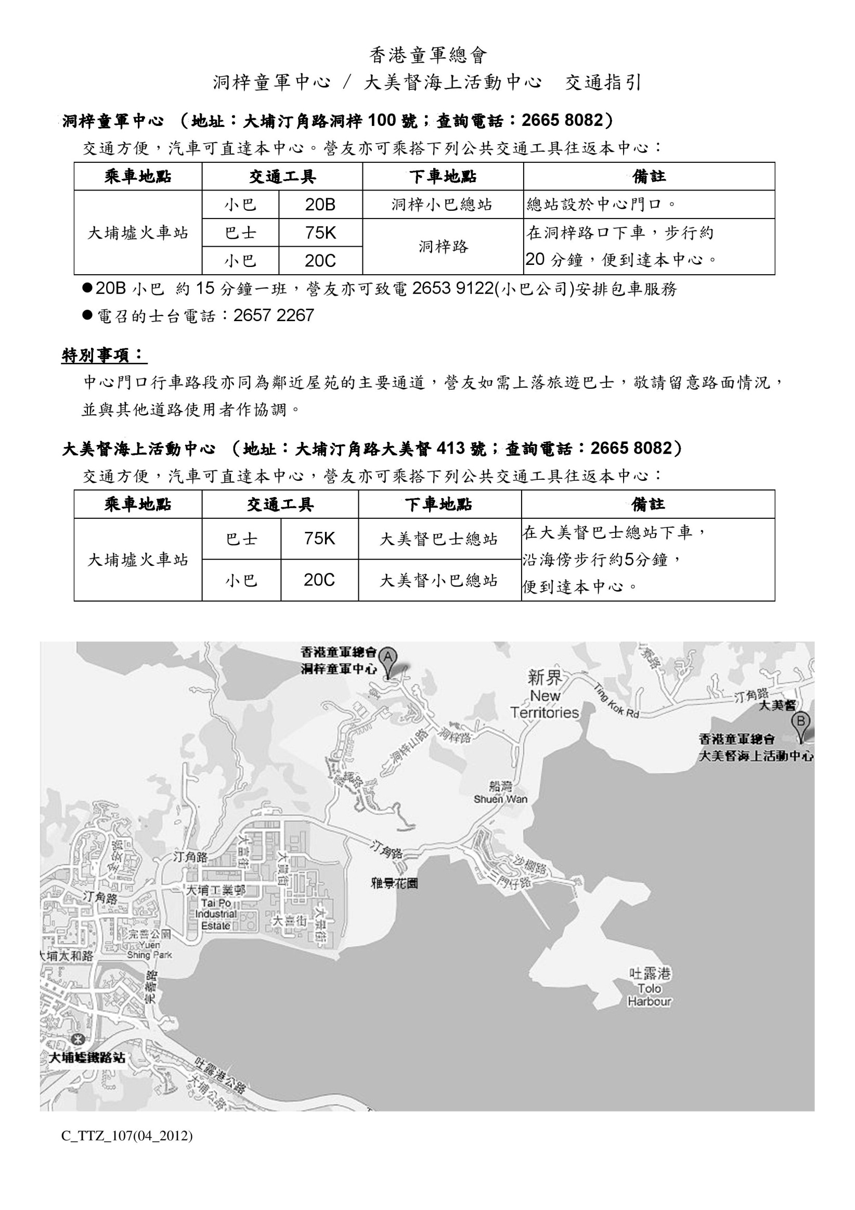
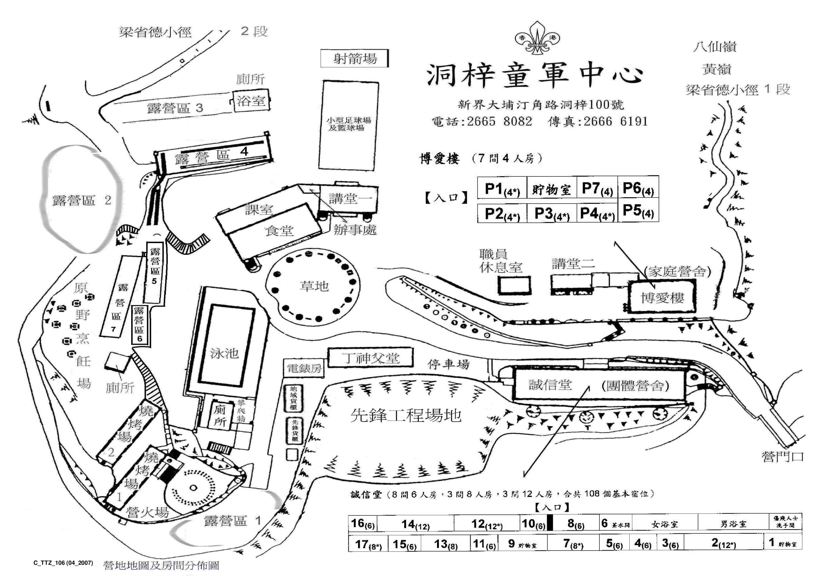

Names of Participants :
Lion Patrol: 李明心, 文智達, 鍾灝林, 蔣樂心, 袁晧晴, 何卓穎, 侯焯嵐, 李俊輝 (8)
Tiger Patrol: 廖旨翹, 鍾芷昕, 莊汶希, 陳尊正, 蘇國熙, 楊青天, 許恩湲, 吳嫣婷, 鄭卓喬 (9)
Panther Patrol: 李頴琛, 彭尉晴, 李穎婷, 黃知珩, 李子淳, 陳思睿, 符喆淳 (7)
Eagle Patrol: 雷碩輝, 葉朗澄, 郭志皓, 陳婧愷, 何安生 (5)
Deer Patrol: 殷家銘, 吴浚彥, 馮加欣, 阮芊睿, 陳智煊, 陳之晞 (6)
Wolf Patrol: 陳奕廷, 楊俊, 黄燕婷, 曾朗言, 任泳山, 羅智賢 (6)
Ventures: 羅善賢, 曾耀庭, 曾淑賢, 廖子悠, 莫芷伶 (5)
Leaders: 許舜莉, 陳敏英 (2)
Total: (48)

Schedule :
2014-12-20 (SAT)
Time | Event | Remarks
1315 | Assemble at HKUGA College to load patrol gears (patrol box, patrol flag, 竹袋, etc.) onto coach bus | At least 2 members from each patrol be present for loading, assemble in full scout uniform
1325 | Coach bus departs HKUGA College
1400 | Coach bus pick ups other members outside China Travel Agency at Hennessy Road, Wanchai | Assemble in full scout uniform, be punctual, coach bus will not wait for late comers
1500 | Coach bus arrives Tung Tze Scout Centre & check in
1530-1550 | Group flag hoisting, allocate campsite
1550-1755 | Pitch tents & build work table | -Each patrol to pitch one A tent & one Mogul tent, one for male & one for female (tents allocated by TC)  -Each patrol to build one bamboo work table & hoist patrol flag  -Ventures pitch two Finland jamboree big tents & group 天幕
1755 | Patrol flag lowering  Group flag lowering
1800-2100 | BBQ | With cubs, foods & gears provided by camp
2100-2130 | Night activity
2130-2200 | Night dessert | At Tung Tze canteen, with cubs
2200-2250 | Bath, wash up | Hot shower available at campsite
2250-2300 | Night inspection
2300 | Lights out

2014-12-21 (SUN)
0700-0730 | Rise & Shine
0730-0745 | Patrol flag hoisting & morning exercise
0745-0800 | Group flag hoisting
0800-0915 | Breakfast cooking & wash up | Hot drink & hot meal for each patrol
0915-1145 | Pioneering (bridge building)
1145-1300 | Lunch cooking & wash up | Hot drink & hot meal for each patrol
1300-1630 | Group activity hosted by ventures | With cubs
1630-1700 | Preparation for campfire | Each patrol to do one performance
1700-1900 | Dinner cooking & wash up | Hot rice for each patrol
1900-2130 | Campfire with real wood burning | With cubs
2130-2200 | Night dessert | At Tung Tze canteen, with cubs
2200-2250 | Bath, wash up | Hot shower available at campsite
2250-2300 | Night inspection
2300 | Lights out

2014-12-22 (MON)
0700-0730 | Rise & Shine
0730-0745 | Patrol flag hoisting & morning exercise
0745-0800 | Group flag hoisting
0800-0915 | Breakfast cooking & wash up | Hot drink & hot meal for each patrol
0915-1000 | Morning inspection
1000-1015 | Scout Own童軍崇拜會
1015-1130 | Unpitch tents & work table, pack personal gears | Remove battery from lanterns
1130-1200 | Debriefing, group flag lowering, group photo taking | In full scout uniform
1200-1300 | Lunch at Tung Tze canteen | Prepared by Tung Tze, no need for self cooking
1315 | Coach bus departs Tung Tze Scout Centre
About 1400 | Arrive outside China Travel Agency at Hennessy Road, Wanchai | Take dirty cookset back home for cleaning & drying  Take water bag back home for drying
About 1435 | Arrive HKUGA College to unload gears back to storeroom | At least 2 members from each patrol be present for unloading

