229 Scout Orientation Camp 2009
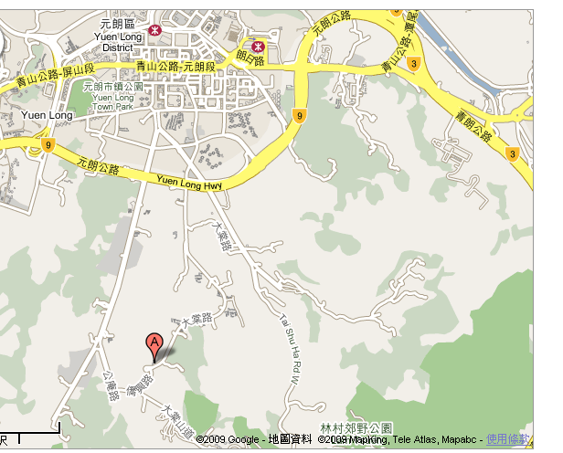
Dates: 10-11 October 2009, SAT – SUN
Venue: 蔡志明聯光童軍中心,
Choi Chee Ming Luen Kwong Scout Centre
元朗大棠道大棠村1 號
http://www.scout.org.hk/chi/venue/cac/ccmlksc/
Transportation: Booked Coach.

Assembly: 1. HKUGA: assemble at 11 am to gather gears and depart at 1:30pm
2. Wanchai outside China Travel: assemble at 1:30 pm, depart at 1:45pm
3. Cox's Road opposite to DGS (the big tree): assemble at 1:45pm, depart at 2:00
Dismissal: 14:00 ~ 14:45 on 11 Oct (Sun) at different dismissal point

Program:
Date | Time | Activities | Remarks
10 Oct. | 1100 | Assemble at UGAC to collect camping gear | In Full Scout Uniform
 | 1330 | Assemble at Wanchai outside China Travel | In Full Scout Uniform
 | 1345 | Assemble at Cox's Road opposite to DGS  (the big tree) | In Full Scout Uniform
 | 1500 | Arrive at CCM LK Scout Centre Campsite
 | 1515 | Arrival Inspection, Group flag hoisting, | SPL
 | 1530 | Pitch Tent | Tent 營x 2-3,
 | 1600 | Setup campsite  PL/APLs to coach members | Clothes and shoe rack衣物鞋架, Kitchen table炊事枱, (Only)
 | 1700 | Checking the build camp craft
 | 1715 | Flag lowering降旗 | SPL
 | 1720 | Preparation for dinner and dinner time  (with 3 dishes + 1 soup) | @ petrol should prepare food for 1 more people
 | 1945 | Cleaning up
 | 2030 | Rest
 | 2100 | Night Game & Singing Together | Prepared by @ Patrol
 | 2230 | Night inspection on tent & tidy up
 | 2300 | Bed time
11 Oct. | 0700 | Wake up, Flag hoisting / Morning exercise | SPL, PL, APL
 | 0800 | Preparation for Hot Breakfast and breakfast time (with hot food & hot drinks) | @ petrol should prepare food for 1 more people
 | 0900 | Cleaning up and Preparation for morning inspection
 | 0930 | Morning inspection | For SPL Inspection
 | 1000 | 童軍崇拜會
 | 1030 | Team Game | Prepared by @ Patrol
 | 1100 | Special Competition
 | 1145 | Flag lowering降旗
 | 1150 | Strike Tent, Packing up | PL/APLs to teach members how to strike tents, dissemble all setup
 | 1230 | Light lunch (no fire) | (Bring your own lunch)
 | 1245 | Leaving Inspection
 | 1300 | Leave the CCM LK Scout Centre Campsite | In 229 Outing T-shirt
 | 1310 | Take Coach
 | 1400 | Arrive Cox's Road opposite to DGS | Dismiss
 | 1415 | Arrive Wanchai outside China Travel | Dismiss
 | 1445 | Arrive UGAC | Dismiss

Please remember the followings:
1. Bring your OWN lunch for Day 2.
2. Bing at least 1L water; backup food & light weighted rain coat.
3. Wear the Full Scout Uniform, bring 229 Outdoor T-shirt; Sport Shoes; sport wear (NO Jeans)
4. Print your own Orientation Camp program & Game plan.
5. PL & APL needs to prepare a song for the Day 1 “Singing Together” section.
6. Be Prepared yourself for the Orientation Camp & Enjoy it.
7. Leave the Leaders contact to your parents.

Remark:
Public Transportation
乘車地點 | 交通工具 |  | 下車地點
港鐵朗屏站 | 巴士 | K66 | 大棠迴旋處
元朗紅棉圍 (千色廣場對面) | 紅色小巴 | - | 大棠迴旋處

Philip Lai
ASL
5 Oct 2009

